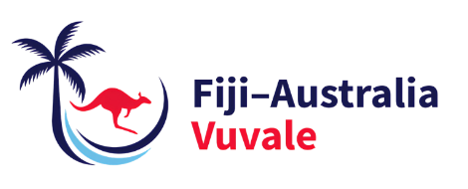

SupportING Fiji’s HIV response

6 August 2026

Suva, Fiji – Today Fiji and Australia jointly opened the Sexual and Reproductive Health (SRH) and HIV Unit in Toorak – a decisive step in Fiji's battle against a generalised HIV epidemic.

Standing alongside Fiji’s Minister for Health and Medical Services, the Hon Dr Ratu Atonio Lalabalavu, Australia’s Minister for Foreign Affairs, Senator the Hon Penny Wong, announced FJD23.5 million in additional funding to back in Fiji’s National HIV Outbreak Response Plan under the Fiji-Australia Vuvale Union.

Through this funding, Australian organisations ASHM Health and Health Equity Matters, together with the United Nations Development Programme, will work in partnership with Fiji to support an effective HIV response.

This includes expanding access to testing and prevention, increasing training and mentoring for health workers, and providing more supplies and direct support to communities, including through faith-based organisations.

This is a joint effort drawing on the strengths of Australian, Pacific and multilateral partners for an integrated response to a complex challenge.

“Communities are not simply beneficiaries of Fiji’s HIV response. They are partners in designing it, delivering it and holding us accountable for its success,” Minister Lalabalavu said.

This FJD23.5 million package is part of the AUD48 million Australian Support for Pacific HIV Action initiative announced on World AIDS Day last year.

“A strong and effective HIV response in Fiji helps build a healthier, more resilient Pacific,” Minister Wong said.

This is the Vuvale Union in action – working together to address shared challenges and deliver real benefits for our communities and our region.

ENDS

For more information:
Public Affairs Team
Australian High Commission, Fiji
public-affairs-suva@dfat.gov.au

